**Cora Z7-07S-Board-Installation Procedure**

To install the Cora Z7-07S board in Vivado 2022.1, it is necessary to accomplish the following steps:

**Step 1: Download the Digilent Board Files**

1. Visit the Digilent GitHub repository for Vivado board files: [Digilent Vivado-Boards](https://github.com/Digilent/vivado-boards).
2. Download the repository as a ZIP file or clone it using Git:
   * To download as a ZIP file, click on the "Code" button and select "Download ZIP".

**Step 2: Extract and Install the Board Files**

1. If you downloaded the ZIP file, extract it to a convenient location on your computer.
2. As shown in Fig.1, locate two folders of 1-Cora-Z7-07S-Master.xdc and 2-folder of cora-Z7-07s in C:\Xilinx\) then you can see the Cora Z7-07S in the Boards

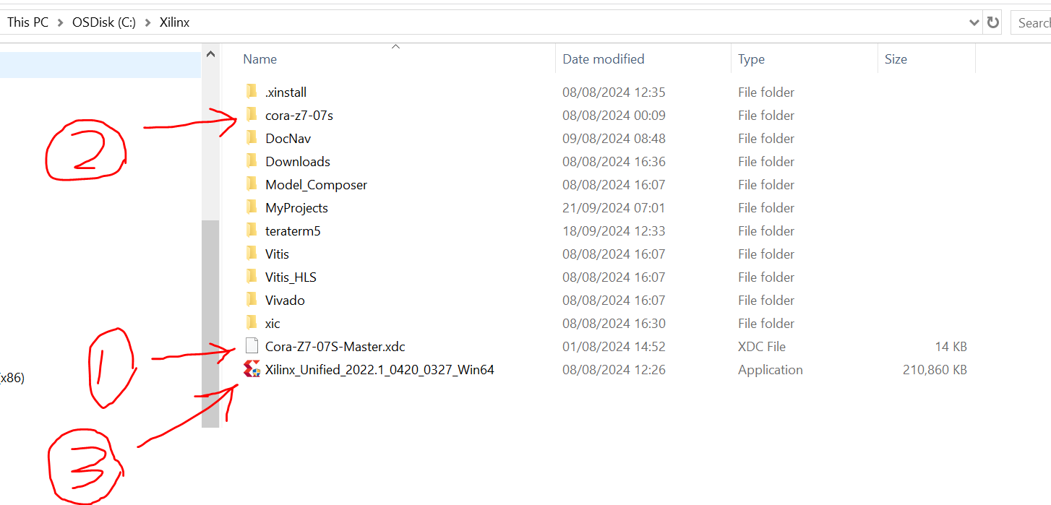

Fig. 1: Insert Master board and file in the folder

**Step 3: Installing Vivado-Vitis**

1. Download the desired [Vivado 2022.1](https://www.xilinx.com/support/download/index.html/content/xilinx/en/downloadNav/vivado-design-tools/archive.html).
2. Run the file Vivado in C:\\Xilinx
3. Depending on the strength of the PC or laptop, installation (Fig.2,3) of Vivado can take 9 hours.

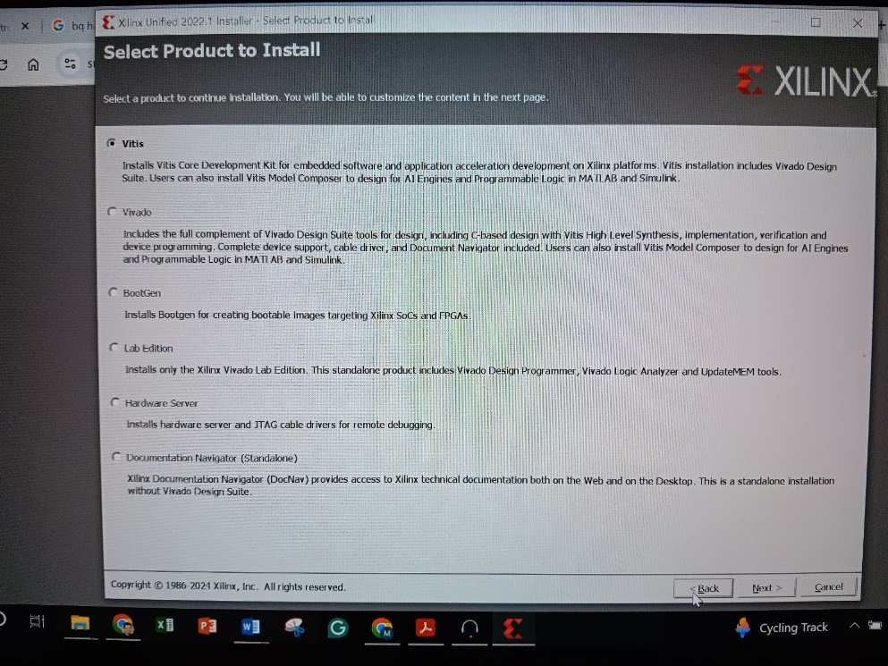

Fig. 2: Select Vitis for installation

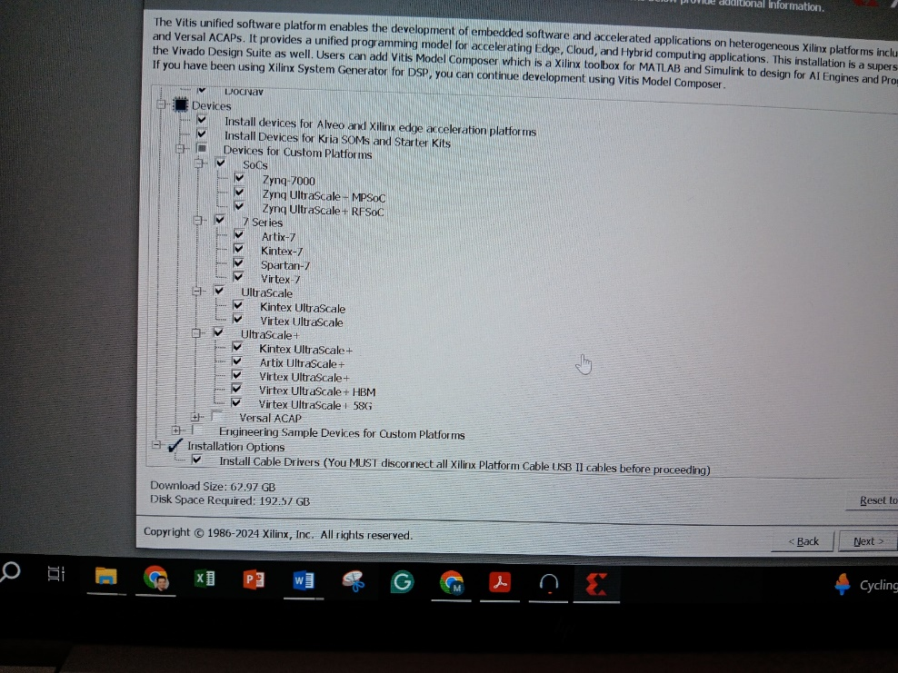

Fig. 3: Untick the unnecessary items in Vitis installation